|  |
| --- |
| Student Name: Abdallah SalhabStudent ID: 21110181  Section #: 6 |

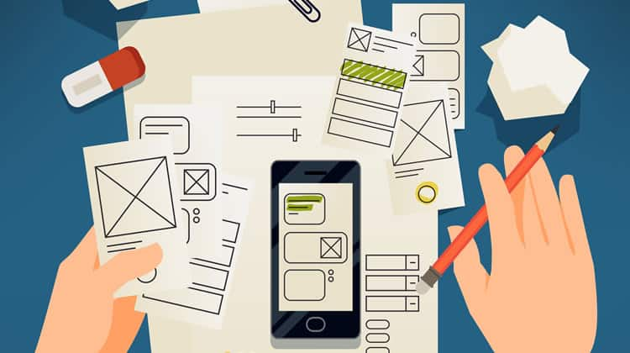

Prototyping – RQF 2019

Assignment 1

Spring 2023-2024

Contents

**1-** **Different Forms of prototyping** 2

1.1 Recognise the different forms of prototyping, their purpose, their advantages and disadvantages, their testing outcomes. 2

1.2 Evaluate the Standard Prototyping tools by providing a brief explanation about each tool and how they can be used in identifying and testing user requirements effectively. 2

**2-** **Review different end user categorizations, classifications and behavior modelling techniques.** 3

**3-** **Examine available prototyping methodologies to test with a specific end user from the user population.** 3

**4-** **Prototyping Plan** 3

4.1 Generic Description of Your Product Idea That Is Being Developed. 3

4.2 Identify your product end users by choosing the suitable end user categorizations, classifications (Segmentation, persona canvas, The value proposition canvas, customer journey map….) and behavior modelling techniques (BJ Fogg’s Behavior model), **choose the suitable ones not necessarily all of them.** 3

4.3 Determine the suitable methodology (Rapid throwaway prototype Evolutionary prototype Incremental prototype Extreme prototype), **choose the suitable one.** 3

4.4 Outline the right tools to prototype your idea (example, JustInMind, Figma, Mockups…) 4

4.5 Plan your prototype evaluation methods (Testing methods: Usability Testing, Focus Groups, beta Testing, A/B Testing, Surveys), **choose the suitable ones not necessarily all of them.** 4

**5-** **evaluate the impact of common prototyping methodology within the software development lifecycle.** 4

**6-** **Low-fidelity Wireframe** 4

6.1 Wireframes screenshots before applying feedback. 4

6.2 Iteration 1 4

6.2.1 Feedback – outline the end users’ feedback on the first iteration of your wireframe. 4

6.3 iteration 2 5

6.3.1 Feedback – outline the end users’ feedback on the second iteration of your wireframe. 5

6.4 Screenshots after applying feedback (of the updated wireframes only) 5

**7-** **Mid-fidelity Mock-up** 5

7.1 Mockups screenshots before applying feedback. 5

7.2 Iteration 1 5

7.2.1 Feedback - outline the end users’ feedback on the first iteration of your Mockup. 5

7.3 iteration 2 5

7.3.1 Feedback- - outline the end users’ feedback on the second iteration of your Mockup. 5

7.4 Screenshots after applying feedback (of the updated mockups only). 5

**8-** **High-fidelity Prototype** 6

8.1 Outline the added features to build your high-fidelity prototype. (What are the interactions, validations added to your prototype to make it similar to the final product) 6

8.2 Analyze end-user feedback from multiple iterations of your prototype and undertake a critical review and compare your final prototype and your test results with your original plan. 6

**9-** **Critically evaluate the overall process of your prototype and discuss your insight using prototyping** 6

**References** 6

# **Different Forms of prototyping**

## 1.1 Recognise the different forms of prototyping, their purpose, their advantages and disadvantages, their testing outcomes.

**(A)**

**\*Low fidelity prototypes:**

A low-fidelity prototype, an important step in the design thinking process, is a simple diagram used in the early stages of designing the concept.it is used to quickly test an idea, identify gaps and pitfalls. low-fidelity prototyping helps in innovating and making the basic page layout, content organization, and user flow.

**The Purpose:**  
They are mainly used at the early stages of the design process to sow the concept of the system and to gather feedback early in the design process.

**Advantages:**

-Collect relevant user feedback quickly.

-Lower the risk of new product development

-Assist members of the product team in avoiding time-consuming and expensive adjustments later in the design and development process to streamline workflows.

-Make quick adjustments easily.

**Disadvantages:**

-Lack of detail can lead to misunderstandings, may not accurately represent the final product

-limited interactivity

- lack realism and are difficult to use for user input

-it can oversimplify a complex problem

**Testing outcome:**

Determine usability problems, get input on fundamental features, and confirm conceptual ideas, give a first view on how the layout would look and test the value proposition.

**\*High fidelity prototypes:**

A refined model of your finished product is called a high-fidelity prototype. Real content and visual design elements give the final product's appearance and feel. A working simulation, realistic and engagement offer a more realistic user experience for testing.

**The Purpose:**

They are used to test specific features functionalities and interactions in detail.

**Advantages:**

-actual view of the final user experience;

-accurate user feedback and usability testing;

-effective stakeholder communication of the final design concept.

-speed product development.

**Disadvantages:**

-take a long time to develop

-are expensive to develop

- can distract testers' attention with decorative details

-might not be as scalable as possible.

**Testing outcome:**

Evaluate user interactions, get input on visual design components, and try out certain features and to make sure the functionalities are in good working order, test the usability.

**\* Feasibility prototype:**

In order to assess attainability and push boundaries, a feasibility prototype is typically developed when developing algorithms, strategies, or architectural designs, it is written to see if the program is feasible and to better understand technical risk.

**The Purpose:**

Before committing to full development, feasibility prototypes are made to determine whether a particular technical approach or concept is possible.

**Advantages:**

-used to verify the possibility of a software before committing all the resources to it.

-can help in defining the scope of the software project.

-helps avoiding technical challenges in the early stages of development.

**Disadvantages:**

**-**time consuming

-resources consuming

-can be miss leading if done incorrectly

**Testing outcome:**

Determine technical limitations, spot possible obstacles, and verify technical fixes.

**\*Live data prototypes:**

A live-data prototype creates dynamic, personalized experiences that are similar to the finished product by utilizing data from databases, APIs, and user input.

**The Purpose:**

Live data prototypes use actual data to assess the system's performance in real-world scenarios. They are employed to verify scalability, performance, and data handling.

**Advantages:**

**-** Decision-makers may provide you with more useful feedback as a result of it.

**-** help you make fewer mistakes and obtain more accurate test results.

- helps identify performance bottlenecks

-validates data integration

**Disadvantages:**

**-** Live data prototypes take longer to complete.

-it requires the collection real or simulated data

-complex to set up

-can be resource intrusive.

**Testing outcome:**

Evaluate the system's performance in practical settings, verify the integration and processing of data, and spot any scalability problems, to test the behaviors proved by data.

## 1.2 Evaluate the Standard Prototyping tools by providing a brief explanation about each tool and how they can be used in identifying and testing user requirements effectively.

(B)

FIGMA:

Figma is the best tool for collaborative design when creating meaningful things. It makes it easy to create, prototype, develop, and gather feedback all in one seamless step, prototyping tools from Figma make it simple to create and share interactive, high-fidelity, no-code prototypes.

Advantages:

- User-Friendly Interface

- Simple to share files

- has all the tools to develop and design prototypes

-no need for experience

-there is a free version

Disadvantages:

-can’t work offline

-lacks the compatibility with deferent programs

-it requires a decent ram and graphics card

-not all the features are free.

ADOBE XD:

Adobe XD is a designing and prototyping tool that allows designers to create interactive experiences for websites, mobile apps and more. With easy-to-use interface and a lot of helpful features Adobe XD is one of the best solutions for designing, prototyping, and sharing user experiences.

Advantages:

- Fits in well with the rest of the Adobe Creative software

-has an interactive interface

-good layout

-good designing tools

-cross platform compatibility

-user centric design

Disadvantages:

-limited free plan, the plan is expensive

-you can't make customized shapes

-no way to deal with the CSS

It is easy to use this tool for testing user requirements because the prototype can have some functionality and interactions that the user could use to test the prototype, using the tools can make the communication with the users or stake holder easier and to make them better understand the design so they can give feed back to the developers, they make the users and stack holders involvement easier for them to give feedback and the developers can add iterations and updates to the prototype and the continue the testing.

# **Review different end user categorizations, classifications and behavior modelling techniques.**

**(C)**

**End user categorizations, classifications:**

**Segmentation:**

It is the process of separating the end users into groups or segments based on shared characteristics.

Demographic segmentation:

In this type of segmentation, we overlook users based on their age group (teenagers, millennials...), we also focus on the gender to differentiate between male and female users in some situations, also grouping people by their job title or the industry they work in, and their income level also grouping them by their educational level.

Geographical segmentation:

Classifying users based on their country, city, state and neighborhood.

Psychographic segmentation:

Categorizing people according to their values and beliefs and their type of personality.

Behavioral segmentation:

Categorizing people on their frequent actions, habits, patterns and behaviors.

Lifestyle segmentation:

Categorizing people according to their interests and activities.

**User personas:**

User personas are a tool to represent users that ideal, they will use your product and they need it, they are chosen according to the segmentation, the personas talk about the user, their information, needs, frustrations, habits, feelings...

Personas are made to further understand the target audience needs, behaviors. To make the expectations of the product clear and to make better desertions toward the vision.

**Value proposition canvas:**

It is a framework that ensures that the final product or service is made to fit the customers values and needs.

There are two parts firstly the customer profile that shows the customers Pains, gains and jobs, and there is the value map that talks about the product or service itself, it shows the gain creators, pain relievers and the products and services. And if they fit together then the product or the service is exactly what the customer wants.

**Behavioral modeling techniques:**

It is a technique that is used to help explain the why and how the users make decisions, and using this data the companies can predict the user's future actions.

Different types of customer behavior predictions:

Churn:

Customer churn is when a customer is not your customer anymore, the number of customers who became inactive over a period is called churn rate, the companies try to make the churn rate as low as possible and they try to understand the reason to prevent it.

Conversion:

Conversion is when customers complete the goals the company sets to them; like signing up to a program; conversion analysis is set to see which customers will convert and it allows for better understanding of the customer that convert, and it is helpful when making campaigns so they can make then on the segments that will convert.

Reactivation:

When a customer becomes active after he was inactive, it is important to know why they became active again because the company can use this to make more customers active again.

Future value:

Prediction of the customer's future revenues that is expected from him during a period.

User modeling approaches:

Relevance feedback: finding out what people want and how they respond to queries and feedback.

Mobile environment user modeling: using a system for mobile environment to see how user behaviors change in deferent circumstances.

Demographic user modeling: Demographic research statistics related to education, age, gender...

Search engine and recommender engine/ social networks.

Fogg’s behavior model:

This model most important implication is that it helps to understand what stops people from making their desires and to understand what triggers can bring motivation to an action.

There are three elements to Fogg behavior technique:

Motivation: the drive that moves someone to do an action

Ability: whether it is hard or easy for someone to do an action

Trigger: something that promotes the doing of an action

And if these three elements combine in something; the motivation, and the user is able to do the thing and something triggered him to do it then he will do it.

A psychoanalytical model:

Iti s a model that tries to figure out why the customers buy certain things base on hidden feelings and desires.

# **Explore a specific end user and an appropriate prototyping methodology to test with a specific end user**

**(D)**

**Rapid throwaway prototyping:**

A rapid throwaway prototype methodology is a method that involves creating a fast and easy prototype of a feature or a functionality to test it then to discard it.

This methodology is helpful if the developer needs clarification about the products detail like the functionality or a feature, it is also helpful when trying to innovate an idea, so the developers use this prototyping methodology to test their idea and to check if it is possible to implement.

The process of this prototyping methodology is to gather the requirement then, creating a basic design after that, making the prototype next, test and review the prototype to get the feedback on it finally, discard it and use the insights you learned on the product.

Advantages:

-quick feedback from the stakeholders.

-validates initial requirements

-encourages innovation

-cost effective

Disadvantages:

-waste of resources

-lack of documentation

**Evolutionary prototyping:**

It is a prototyping methodology where a prototype is started and is it’s self refined and improved on through a couple of iteration, the improvement comes from the users and stakeholders constant feedback.

The process of this methodology is to gather the initial requirements then from it build the initial prototype and after that review it with the stakeholders and gather more feedback and use it to refine the prototype, after doing this for a couple of time the prototype should be refined and ready to make the final product.

Advantages:

-early and continuous user feedback

-ensures that the final product meets the users needs and expectations.

Disadvantages:

-time consuming

-needs high level of communication and collaboration

**Incremental prototyping:**

It is a prototyping methodology in which the deferent components or features or parts is separated into smaller prototypes and is developed all the same time, and merged together after they are finished.

Advantages:

-backing down a the project into parts makes developing each one easier

-reduces time of implementing the user feedback

Disadvantage:

-the risk of having deferent looks and feels of the deferent parts because they were developed separately

-there must be a good plan and guidelines for this methodology to work

Extreme prototyping:

It is the process of making a prototype that is very close to the final product, it is meanly used in web development.

It breaks down the development process into three phases:

Firstly, creating the HTML pages

Secondly, programming the pages and making them fully functional using the simulated service layer

Thirdly, implement the services.

# **Prototyping Plan**

## Generic Description of Your Product Idea That Is Being Developed.

the problem:

In Jordan it is always hard to find the medicine the patient wants without going through a couple of pharmacies to check if it’s available this wastes time and energy, and at the end the pharmacy would not have all the medicines in stock or the pharmacy its self is not working with the insurance company that the patient is with.

The solution:

Is to make a website where the patient could type in his needed medicine and the website would show the pharmacies that have that medicine available; their phone number and their location.

There is one competitor that is a website named Tebcan “طب كان” but it lack good UI and up to date data and does not show if the medicine is in stock, it only shows that the pharmacy sells it, and it does not have a lot of medicines and pharmacies in its data.

## Identify your product end users by choosing the suitable end user categorizations, classifications (Segmentation, persona canvas, The value proposition canvas, customer journey map….) and behavior modelling techniques (BJ Fogg’s Behavior model), **choose the suitable ones not necessarily all of them. Minimum three (Persona, segmentation, value proposition)**

**\*User segmentation:**

**Geographical segmentation:**

Jordan, Amman

**Psychographic segmentation:**

Supportive, trustworthy, have compassion and empathy, responsible, self-caring, decision maker.

**Behavioral segmentation:**

caretaker, prioritize affordability and ease of use, loves to plan before acting, hard worker, helps people.

**Lifestyle segmentation:**

Working in a job, loves his family, always productive, supports his family either with money or with always helping.

The conclusion from the segmentation that the segment we want to focus on at the beginning are the people who lives in Amman, they might be taking care of someone or their self, but they are not reeling on others, so they are supportive and trustworthy, responsible and self-caring, they prioritize affordability and are good planers for their actions, they live in a life with lots of work and they support their families and friends and don't rely on others, and they have a productive life.

**\*Value Proposition Canvas:**

**Customer profile canvas:**

Customer pains:

-Difficulty in finding pharmacies with the required medicine.

-wasting time and effort visiting multiple pharmacies.

-the uncertainty about the medicine availability.

-lack of convenance in contacting pharmacies.

-the struggle in finding a pharmacy with the patient insurance that have all the medicines in stock.

Customer Gains:

-save time and effort searching for the medicine.

-access real time information about the medicine availability.

-conveniently locate the nearest pharmacy that has the medicine.

-easily contact the pharmacies to inquire the medicine.

-easily filter the pharmacies according to the insurance company the patient follows.

Customer Jobs:

-find a medicine quickly.

-locate the nearest pharmacy to buy the medicine.

-obtain contact information for the pharmacies.

**Value map:**

Products and services:

-search for the needed medicine's function.

-pharmacy filter based on the insurance company.

-display pharmacies names and contact details (phone number, address)

-use location to locate the nearest pharmacy with the medicine.

Pain relievers:

-instantly find pharmacies with the medicine needed.

-eliminate the need to visit multiple pharmacies.

-provide certainty about the medicine availability.

-offer convenient access to the pharmacy's contacts.

-filtering out the pharmacies that does not work with the insurance company.

Gain creators:

- Make the search process more efficient to save time and effort.

- Give accurate and current information about the medicine to ensure peace of mind.

- Increase ease of use by providing location-based results.

- Make it simple and quick to communicate with pharmacies.

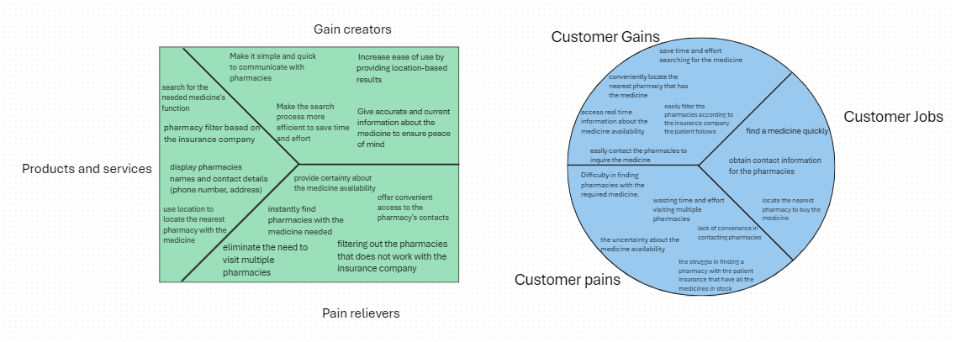

User personas:

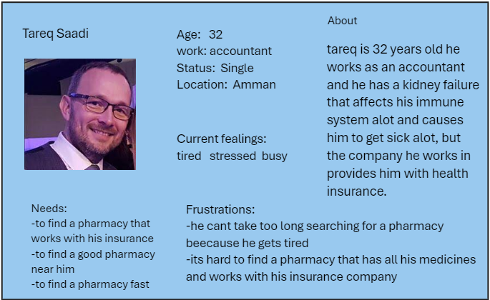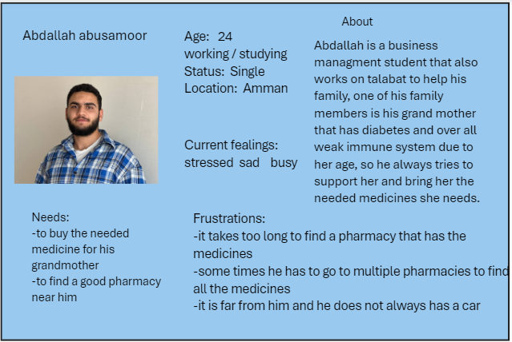

## Determine the suitable methodology (Rapid throwaway prototype Evolutionary prototype Incremental prototype Extreme prototype), **choose the suitable one.**

I will use the evolutionary prototyping methodology so using the initial requirements I will start with doing a simple sketch (wire frame) to make sure that all the needed elements is there and then I will start with the mock up to add logos, colors, designs and meaning full data after that I will proceed with the high fidelity design that will add the movements between the pages and some features. The evolutionary methodology is better to integrate the user feedback as I can get feedback on every iteration and to reduce cost and risk.

## Explore the right tools to prototype your idea (example, JustInMind, Figma, Mockups…)

I am going to use Figma to make my prototype because I am familiar with it, it has great tools, great user interface, does not need to have experience to use it, and has the ability to use plug-ins and it has a lot of shapes that resembles buttons lists check button and more and templates especially using the “Visily” plug-in that has great templates, elements and icons and it has a prototype mode that enables me to connect the pages together easily and then I can display the prototype in inspector mode.

## Plan your prototype evaluation methods (Testing methods: Usability Testing, Focus Groups, beta Testing, A/B Testing, Surveys), **choose the suitable ones not necessarily all of them. Minimum three**

**(E)**

To evaluate and test my prototype to identify any problems to improve them and to do the necessary changes to meet the users needs, I am going to use three deferent testing methods:

Usability testing:

Usability testing is a testing methodology that focuses on testing the functionality of a website, app or any digital product by observing the users as they use it by performing tasks.

usability testing is important to:

-Validate the prototype

-identify issues with complex flows

-validate the user expectations of the product

-catch errors that might not be visible to the designers or developers

I used moderated usability testing to test if the flow of the pages is clear and easy to use and to go from one page to another so I told the users to go from one page to another and they gave me feedback that there was not an exit button from the rating page if they did not want to add a rating, so I added it.

I also asked them to use the feature assuming it fully works by choosing what they want to input and what they want to see as output and all the inputs they want to add had input field in the website and if it was working it will be easy to use. And I mostly used the usability testing in the high-fidelity stage.

**A/B testing:**

A/B testing is used to compare two versions of a web page or product to determine which one is better and would perform better.

I used A/B testing to make my prototype look the best by making A/B testing on the color I chose as a theme to the website between a blue theme or a green theme

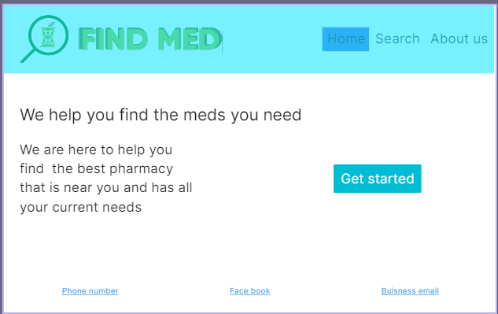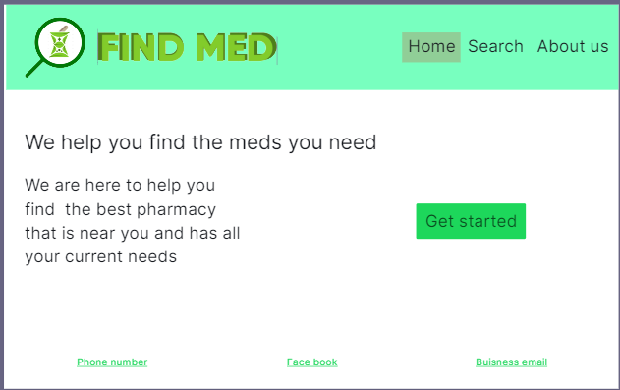and the users chose green because it resembles health better than blue.

I also used A/B testing to choose the logo of the website and those are the two logos



But the users chose the one to the left because it resembled what the website does, and the other logo looks like the website only specialized in eyes medicines.

Interview:

I used the interview at the biggening to choose the user personas and to take their needs on the website the frustrations that they face and the things they want for the website to do, and then I told them the idea of the website and took their feedback and any initial features they need, the interviews of the users gave me important qualitative feedback that I used in my prototype, and I sometimes used the interviews to collect feedback of the prototype at each iteration of the prototyping process, I chose the interviews over the survey because it gives me a better understanding of the user and it gives me qualitative feedback the is useful, and I will know for sure the feedback are from users that would use the product and to random people that might give false feedback because they don't care of the product.

In the future:

I plan to use beta testing to test the product with real users in a real environment to test any bugs and issues before the final relies.

# **evaluate the impact of common prototyping methodology within the software development lifecycle.**

SDLC or software development life cycle provides a flow of deferent phases that the organization run through to provide high quality and tested software with the lowest amount of cost and time.

SDLC runs through 6 phases that is planing, analysis, design, implementation, testing and integration and then the maintenance.

Rapid application development (RAD):

It is a SDLC mode that is incremental, the development of the project functions and component are made in parallel as if they were mini projects, then after they are finished, they are assembled into a working project.

RAD steps:

Define the requirements, prototype, construction, deployment.

RAD model and prototyping:

RAD is a software development model that is based on making prototypes and taking feedback and is less emphasized on planning.

So, through prototyping their goal is to make a working version of the product very fast and then improve on it continually through iterations.

In the prototyping phase of the RAD model the prototypes are built with deferent features and functions that are not restricted to requirements, then they are shown to the clients and users to see whether they like it or not. These prototypes are mostly made to showcase the main features.

Prototyping methodologies have a great impact on the SDLC, they enhance clarity and communication with the users, they enable early validation and refinement, reduce risks, and lead to a higher quality and a more user centric product.

# **Low-fidelity Wireframe**

## 6.1 Wireframes screenshots before applying feedback.

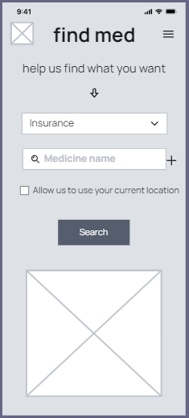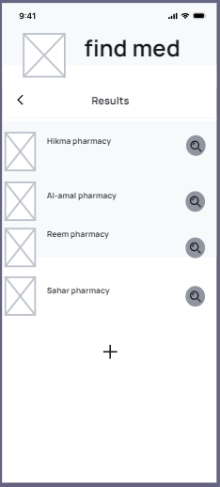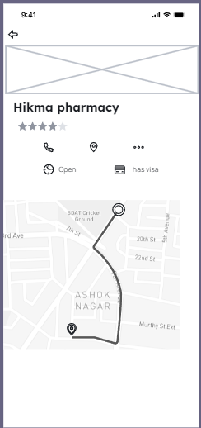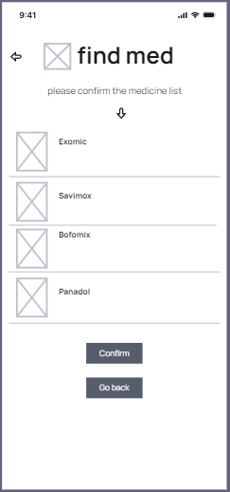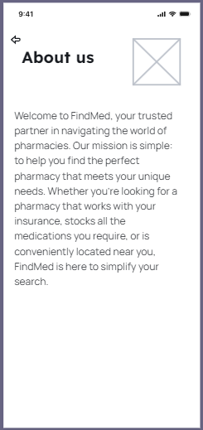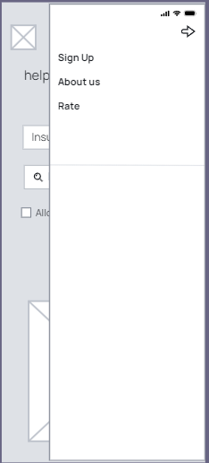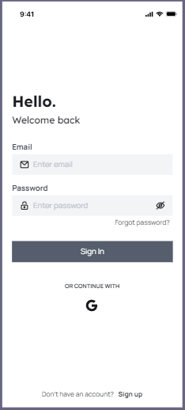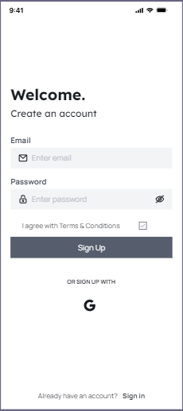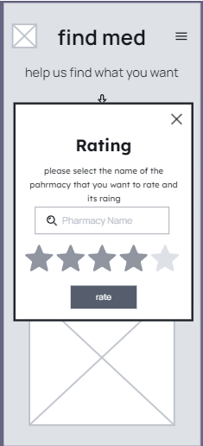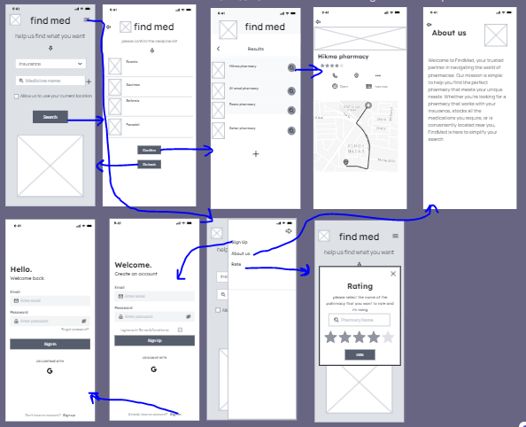

## 6.2 Iteration 1

### 6.2.1 Feedback – outline the end users’ feedback on the first iteration of your wireframe.

The users that helped me in the project are:

*Abdallah abu samour 0786395131

*Rami raied 0790167276

*Tareq saadi * he did want mee to share his phone number.

*DR.laheeb

Rami -show the pharmacy rating in the pharmacy page

Rami -show the selected medicine list

Abdallah -add symbols to the sliding window

DR -make it in a website style

DR -remove the sign in and sign-up pages

## 6.3 iteration 2

### 6.3.1 Feedback – outline the end users’ feedback on the second iteration of your wireframe.

### Rami -put your logo or name on every page

Tareq -show if the pharmacy is open or not

Tareq -show if the pharmacy has a visa card reader or not

DR -remove the slide page

DR - add a header to the pages with buttons to go to the other pages

DR - add a suitable home page that talks about the website

DR – continue to the mid fidelity

## 6.4 Screenshots after applying feedback (of the updated wireframes only)

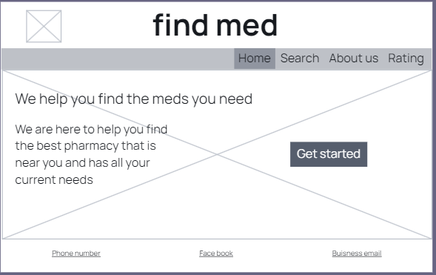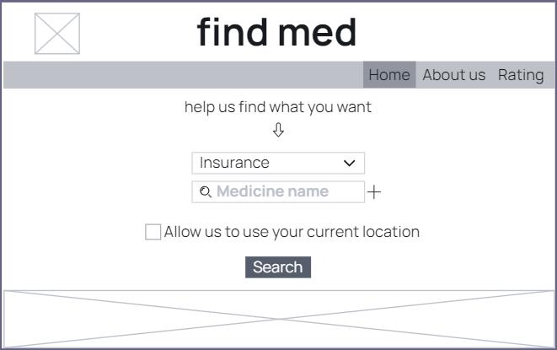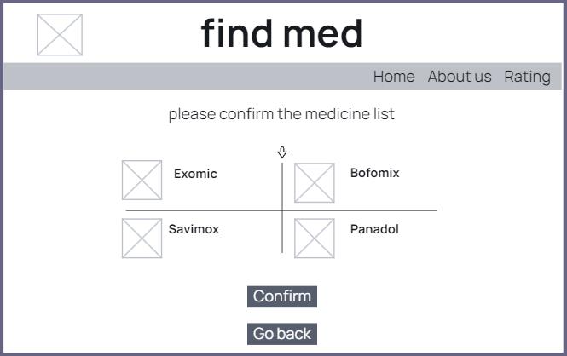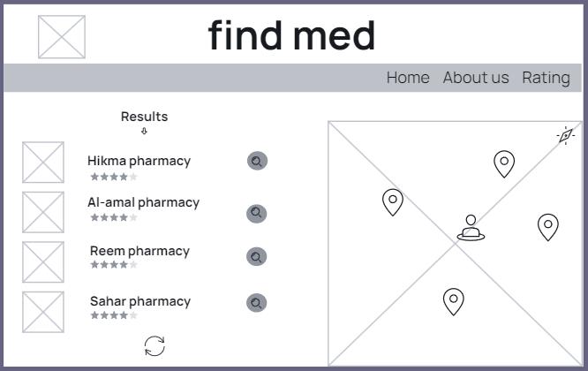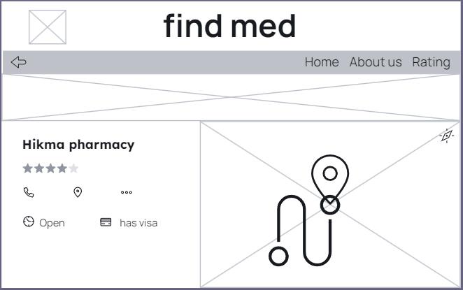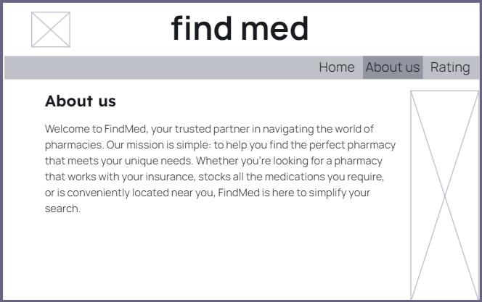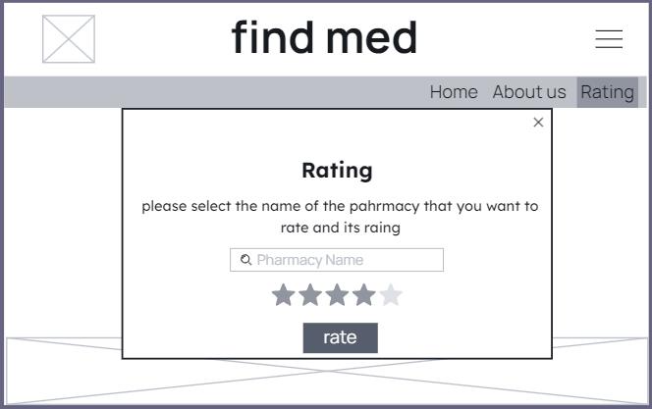

# **Mid-fidelity Mock-up**

## 7.1 Mockups screenshots before applying feedback.

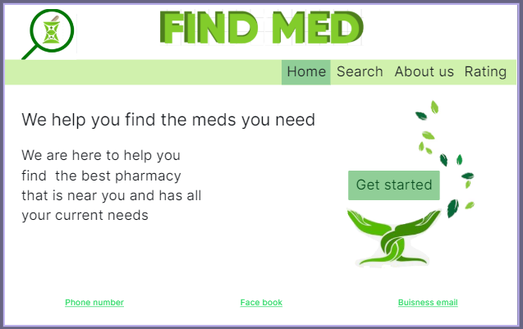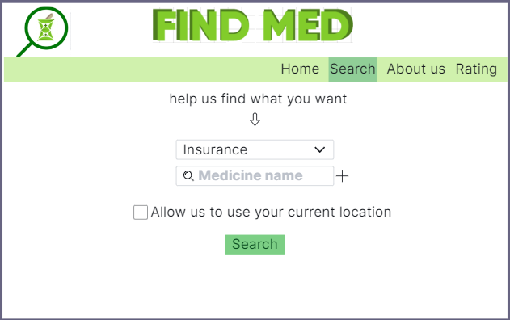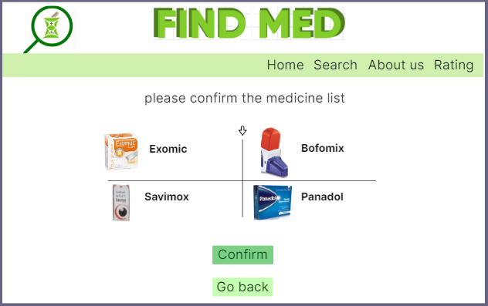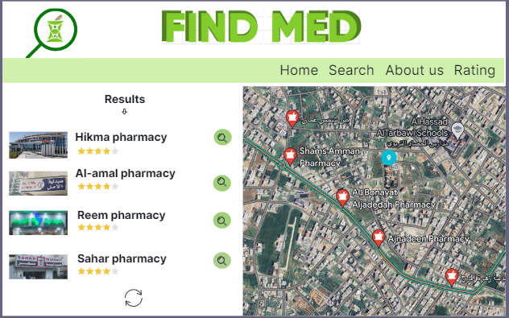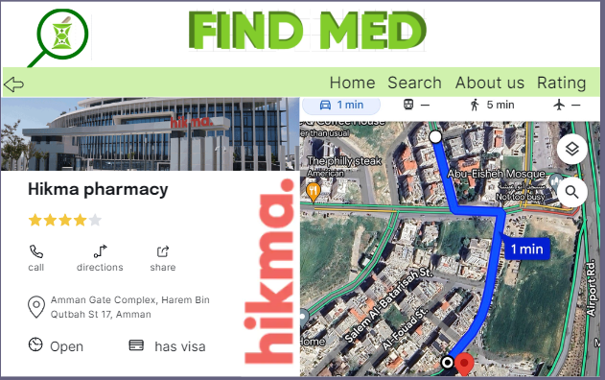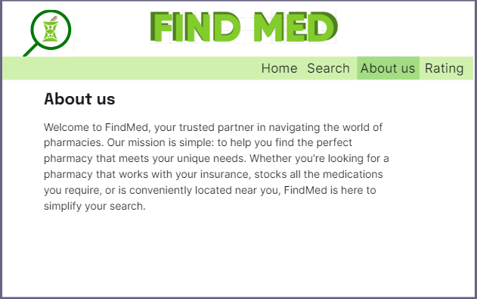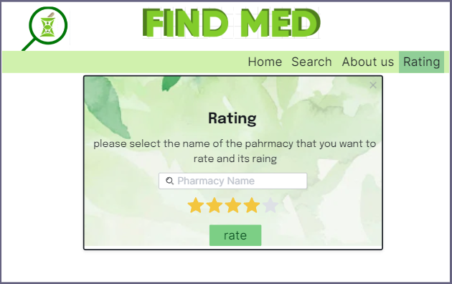

## 7.2 Iteration 1

### 7.2.1 Feedback - outline the end users’ feedback on the first iteration of your Mockup.

### Abdallah-there is a lot of white space in some pages, try to add some designs.

### Rami-change the size and the colors of the text in the main page to make the slogan bigger

DR-change the page header and put the logo inside it

DR-add a background in the main page

DR-make the medicine display a slider and add more of it

DR-change the button in the medicine display page to make it say continue and not confirm

DR-change the about us page

DR-make the rating button inside the pharmacy page

DR-add a footer to all the pages

## 7.3 iteration 2

### 7.3.1 Feedback- - outline the end users’ feedback on the second iteration of your Mockup.

DR -change the footer color to gray

DR –continue to the high fidelity

## 7.4 Screenshots after applying feedback (of the updated mockups only).

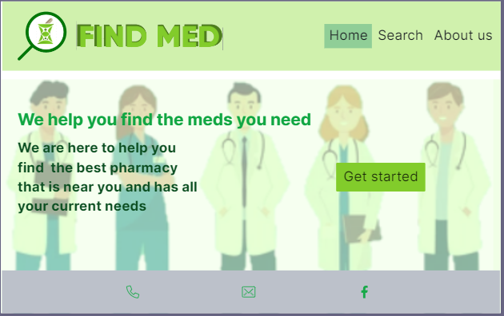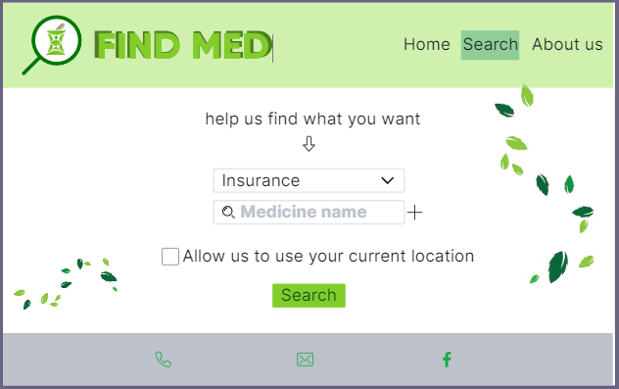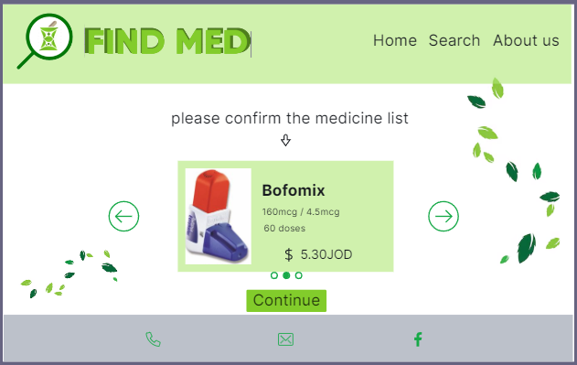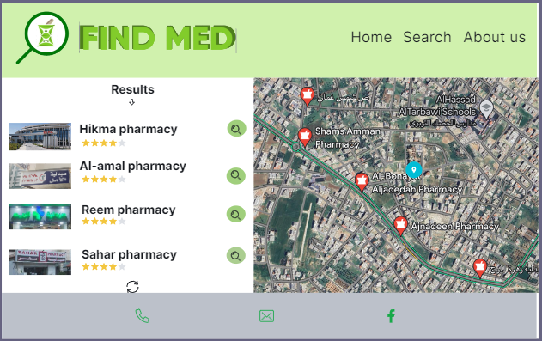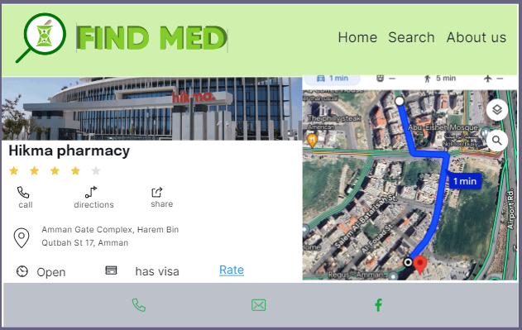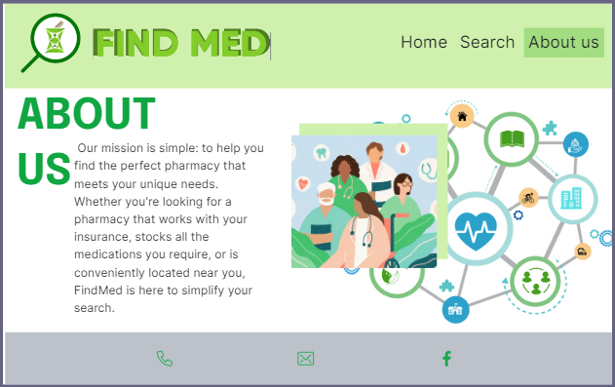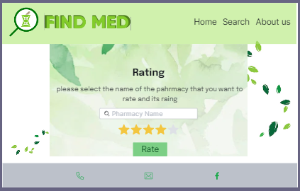

# **High-fidelity Prototype**

## 8.1 Outline the added features to build your high-fidelity prototype. (What are the interactions, validations added to your prototype to make it similar to the final product)

In the high-fidelity prototype, I added a lot of interactions that gives the feel of a complete and refined website but without the function working, and to do this I made the navigation bar work by transferring the user to the needed page, and I made the website workflow of how the flow of page should be by making the main buttons work to transfer the user to the needed page or pop up; like the GET STARTED button in the main page that transfers the user to the page he wants to use the website function.

I did not add a validation to the prototype because of the concept of the website that the user would only enter the website to find a pharmacy that has the medicine he needs, so he does not have to enter any personal data or an account, that is why no validation needed.

## 8.2 Analyze end-user feedback from multiple iterations of your prototype and undertake a critical review and compare your final prototype and your test results with your original plan.

In my prototyping process I took the users feedback on every step of the way of the finished prototype, I started taking feedback when I was developing the Idea, I saw what they needed and added their feedback to the idea, after that in the wireframe I took their feedback on the layout, the pages, the flow and their feedback was reconsidered to make a wireframe that was marginally better that the original one, and in the mock up and after showing them my initial mock up, they gave me more feedback through the deferent iterations that improved the look and feel of the website.

So, the user feedback that I received over the deferent iteration of the prototyping process Improved on my website in a significant way that I could have never Imagined, and I would have not reached this level alone.

My original plan of the project was very basic because I don't have a great imagination of how I would look like, and if I stuck to my original plan without the testing and the feedback the project would have been a complete failure, the testing of the users helped me to determine and to tack important choices that if left un determined might have costed a lot to fix later, and the testing helped me identify any gapes or bugs that could have ruined the final product.

In conclusion all the userfeedback, the testing results, contributed on the making of a much better version of the final product that have a professional look and feel.

# **Critically evaluate the overall process of your prototype and discuss your insight using prototyping.**

In the beginning of the prototyping process, I was confused and I did not imagine how I would get to the final of the course and to have a finished prototype, so in the Ideation process I needed to find a useful idea that has an impact on the users, and it would be beneficial to them and a lot of people would use, so I shed the lights on a problem that I actually face a lot and a number of people that I know have faced that is I could never find a pharmacy that is close to me and have all my medicine and works with my insurance, so I searched for a solution for it and I did not find any respectable ones, so my idea was to make a website that would solve this problem.

To validate if my solution is important to a lot of people, I used user segmentation to see who are the suers that I must focus on and would need my website, and through it I found the user personas that I sat with to validate my idea and to find the values they have.

After that I started with the low fidelity prototype that is a wireframe of the website that I built to meet the user's values, expectations and needs, and I also got and integrated the users feedback in every iteration of the prototype, then I made the initial mock up and took the users feedback on it to improve the look and feel of it, finally I made the high fidelity prototype that added some interactions to the prototype to make it look like the final product.

Throughout the prototyping process I conducted test on the prototype with the help of the users such as usability testing, A/B testing, interviews or surveys and a plan to make beta testing, all of then took the project to a whole new level of professionalism.

Prototyping is very important process that emphasizes the importance of keeping the end user in mind though out the designing process, and it is very helpful and mediating risks and issues early, such as usability problems and design issues, prototyping is saving time and effort and cost on the developers by preventing and major redesigns in the late stages of development, finally, prototyping encourages innovation by giving the developers a chance to experiment and it gives them flexibility with the help of the users feedback to develop a successful product.

# **References**

(A)

https://www.protopie.io/blog/low-fidelity-vs-high-fidelity-prototyping

https://www.figma.com/resource-library/low-fidelity-prototyping/

https://miro.com/prototypes/low-fidelity-vs-high-fidelity-prototypes/

https://www.protopie.io/blog/low-fidelity-vs-high-fidelity-prototyping

https://testsigma.com/blog/prototype-testing/

https://www.uxpin.com/studio/blog/live-data-prototype/

https://www.uxpin.com/studio/blog/live-data-prototype/#:~:text=Prototyping%20with%20live%2Ddata%20has,buy%2Din%20for%20that%20approach.

(B)https://www.fita.in/what-is-figma-advantages-and-disadvantages/

(C)https://www.optimove.com/resources/learning-center/customer-behavior-modeling

https://www.questionpro.com/blog/consumer-behavior-models/

(D)https://www.visily.ai/blog/throwaway-prototyping/

https://www.slideshare.net/slideshow/topic-1-what-is-evolutionary-prototypingpptx/263687821

https://www.andplus.com/blog/4-types-of-prototyping

https://en.wikipedia.org/wiki/Software_prototyping#:~:text=Extreme%20prototyping%20as%20a%20development,consists%20mainly%20of%20HTML%20pages.

(E)https://www.hotjar.com/usability-testing/